User Guide

Weather Information

Management in East Africa (WIMEA)

Version 1.0

August 2016

**Introduction to the User's Guide**

**WI**MEA is a Weather Information Management System in East Africa which aims at improving the accuracy and reliability of the weather information by communities in the East African region through suitable use of ICTs.

WIMEA has three (3) different Versions, all with different interfaces but with the same functionalities of the system. These Versions include WIMEA Web, WIMEA Desktop and WIMEA Mobile. The Desktop and Mobile Version of the system are majorly used for climatic data entry into the various forms of the system while the Web Version will have all the system functionalities ranging from data entry, to view of data entry reports and all administrative roles of the system.

WIMEA stores all its data which has been input from the different versions of the system in one central web server (repository). Data submitted by a user will be transmitted to this central web server through internet connection from any of the three system versions. However the Mobile and Desktop system Versions can enable users submit data even without accessible to internet and later when you are connected to the internet, the data will be transmitted to the central web server. Observed Data (Reports) stored on the web server can be downloaded to a Personal Computer (PC) over the internet of which this data will be stored in MS Excel.

**Purpose of this guide**

This guide describes how to use the WIMEA system to enter climatic data and how you can use the system to produce informative reports and analysis of the data that has been input from all the different forms of the system.

This guide is intended for users of the system, and assumes that the system has already been set up correctly by the systems administrator of your organisation.

**Layout of this guide**

This guide deals specifically with how you can input data and how you can produce reports from the data input in the system using one of the versions of the system. It is divided in the following sections;

* **Logging into WIMEA System:** Shows how you can be able to log into the different Versions of the WIMEA System (Web, Desktop, and Mobile).
* **The Data-entry facility:** Describes in detail how to input data using the different system versions, including a description of all the standard data entry forms.
* **Reports:** Describes the standard reports, Which extract information from the

Database and present it in various forms. The section gives details of how to use the

Reports and examples of the results that they produce.

* **Administration:** Describes administration functions, such as defining users of the

System, and updating the metadata (information about stations, elements and other

Entities described in the database).

**How to Start the WIMEA System versions**

In order to log into one of the WIMEA System Versions your System Administrator will have to first create user credentials (User Email and Password) for each user using the Web Version of the System. The System Administrator will supply these Log In credentials to users, later the users can log into the Web Version of the system using the Log In credentials provided from the system administrator and they can also download the Desktop and Mobile Version of the system from the Download Icon on the Web Version of the system and thereafter install these versions on the applicable platform, but putting into consideration that login credentials should be the same across all the WIMEA versions of the system.

**WIMEA Web Version Log In**: Here the system administrator will have to provide the IP Address (Domain) where the system will have been hosted to the user and there after a user will be required to have internet Access to be able to enter the IP Address into a web browser like Mozilla Firefox or Internet Explorer to be able to access the Log In Page of the WIMEA Web Version System on a Computer like displayed below.

**WIMEA Desktop Version Log In:** On successful installation of the Desktop WIMEA System Version on the computer, To start the program, click on the WIMEA icon on the desktop, or use one of the other Windows methods for starting a program. When the program is started a login dialogue appears as below.

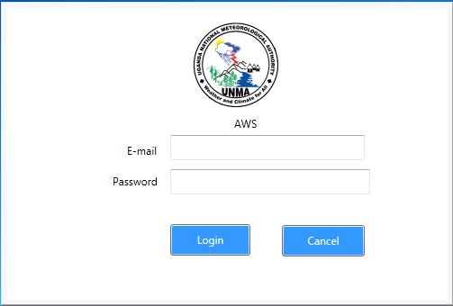

**WIMEA Mobile Version Log In:** After a successful installation of the system on the smart mobile Phone, To start the program, click on the WIMEA icon on the phone When the program is started the login form appears.

For both the Desktop and Mobile WIMEA Versions, the first time of installation the system a user will be required to first have internet connection for successful log into the system, else a user will be notified of inaccessible to internet connection.

If you enter an invalid Email or password, a message will inform you of this and you will be

able to try again for any of the three WIMEA System Versions. Clicking the Cancel button will exit immediately from the WIMEA System Versions.

Once you have entered a valid Email and password, then the WIMEA main window and the Welcome dialogue appear.

#### WIMEA MAIN WINDOW \,z,,,,,,,,,,,,z,z\zmm,m,m,m.>,mM><m<|m,\m\,m.\m,m..m.M,m,<,,M<<,<,>/??? Mmain WIMEA Window are Command Buttons that will enable a user executing some of the system functionalities like Logging \,..>..>.>?./?

,/Out?

When WIMEA is first started, the Welcome Message is displayed first in the area that will be used to display forms or any other menu items of the system.

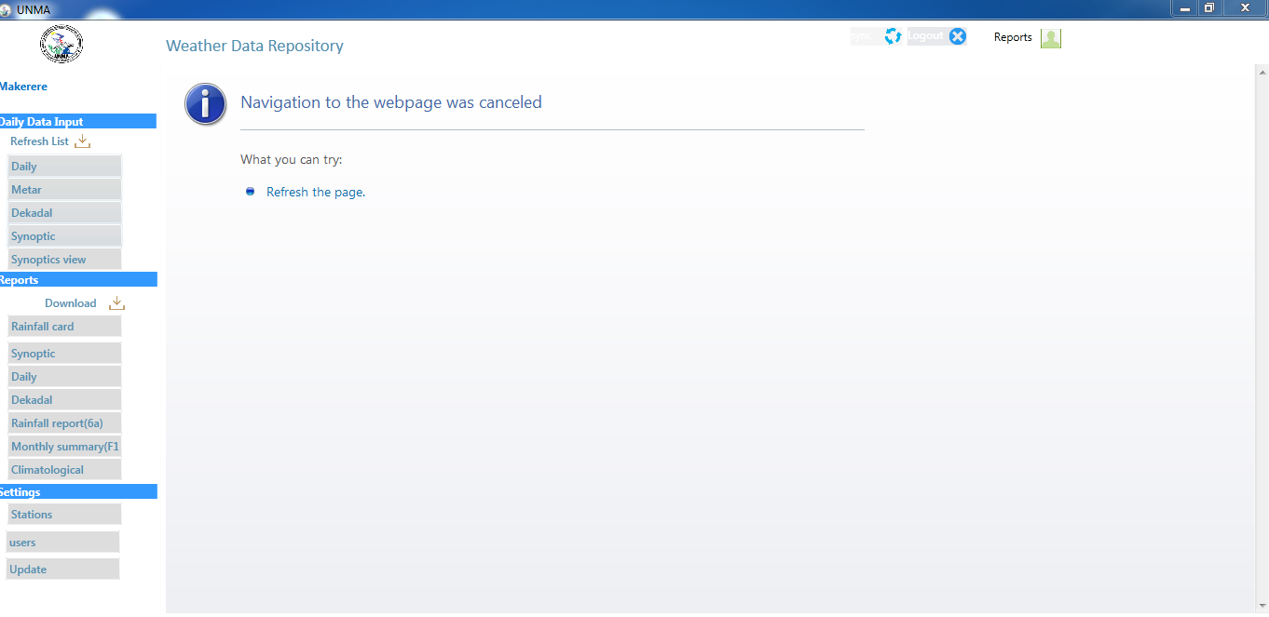

If you are logged in as a user with System Administrator privileges, all the command buttons and menu items will be available. However, if you have logged in as another type of user, you will only be allowed to perform the functions relevant to that user, and some of the menu items will be greyed out to show that you cannot use them.

**Getting Help**

Information about using the WIMEA system is available on-line through the Help facility. This

can be accessed by clicking the Help menu item

To BE CONTINUED.

**Closing the Program**

To finish using the WIMEA program, you can then select the log Out Button that is located in

above the main wimea window.

**DATA ENTRY**

The Data Entry facility enables users to take climatic data that has been supplied on paper forms and input the data via the keyboard into the WIMEA Version systems.

All of the data entry forms share a similar layout across the different WIMEA Versions, making them easy to understand and use. Each data entry form is broken up into the following sections:

**General Information:** At the right or top of the form you will find boxes to input information such as the Station name, Station number, period of data entry (date). These are mostly the header fields.

**Value Boxes:** In the center of the form are the value boxes. This is where a user will enter all the data. These are called the data fields.

**DATA ENTRY FORMS.**

**Daily weather records Form (Daily)**

This form is for recording daily weather records.ie user will be expected to enter data for each day. A screen shoot of this form is shown in Figure 2.

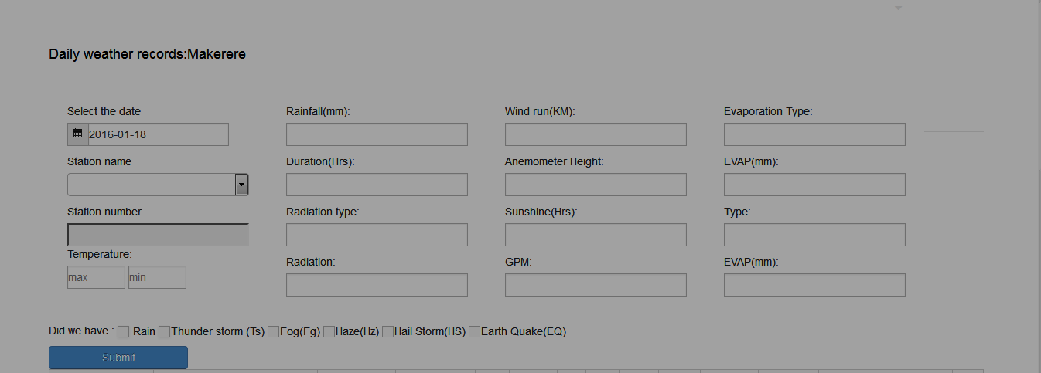

Figure 2: **Daily weather records Form**

1. To begin daily data entry records, select the year, month and day in the under the **“Select the date”.**
2. Next click on the drop down menu arrow located below the “**Station name**” and select the appropriate station.
3. **The “Station number”** will be automatically computed for the user once they select the station name. Of which these will also be got from the Database.
4. Enter the rest of the Data Value Fields as follows.

**Daily weather records Form Value Data Fields.**

|  |  |  |
| --- | --- | --- |
| Data Field Name | Description. | Constraints |
| Temperature | Enter the Maximum and Minimum Temperature in the two text boxes that are located below the **“Temperature”** box. These fields will be stored in the database as Centigrade integers. | 1 to maximum characters |
| Rainfall | Enter Rainfall that will be calculated in Millimeters into the Text box located below the **“Rainfall (mm)”** that will have been observed for that day. | 1 to maximum  characters |
| Duration(HRS) | Enter the Duration in hrs into the text box located below the **“Duration (Hrs)”.** This field will be require a user to enter either the Duration of how long it rained or shined in the day and this will be calculated in Hrs. | 1 to 3 characters |
| Radiation type |  |  |
| Radiation |  |  |
| Wind run(KM) |  |  |
| Anemometer | Enter the Height of the wind. |  |
| Sunshine(Hrs) : |  |  |
| GPM |  |  |
| Evaporation Type |  |  |
| EVAP(mm): |  |  |
| Type: |  |  |
| Rain: like true |  |  |
| Thunder storm (Ts): |  |  |
| 1. Fog(Fg):true 2. Haze(Hz):true 3. Hail Storm(HS):true 4. Earth Quake(EQ): true |  |  |

1. To save your record click the **“Submit”** button.

**Daily periodical rainfall Form**

This form is for record rainfall on a daily basis. As shown in the figure below.

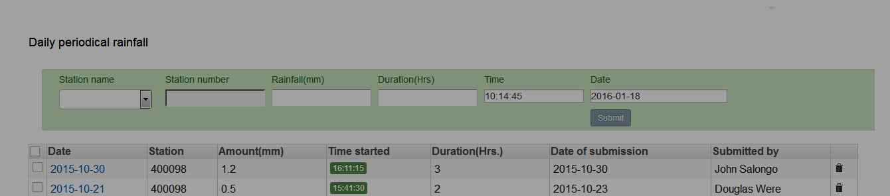

**Figure 3: Daily periodical rainfall Form**

1. To begin daily rainfall data entry, click on the drop down menu arrow located below the “**Station name**” and select the appropriate station.
2. **The “Station number”** will be automatically computed for the user once they select the station name. Of which these will also be got from the Database.
3. Select the year, month and day in the under the **“Select the date”.**
4. Enter the rainfall in millimetres in the text box located below the **“Rainfall(mm)”.**
5. Enter the Duration in hrs into the text box located to the right of the **“Duration(Hrs)”.**This field will be require a user to enter the Duration of how long it rained and this will be calculated in Hrs.
6. Enter the Time when it started raining into the text box located below the **“Time”** box.
7. To save your record and exit the form click the **“Submit”** button.
8. You can also be able to view the data you have just entered below the form.

**Metar Book (Observed every hour) Aviation Routine Weather Report Form**

This form is for recording hourly data ie you will be expected to enter 24 records for each day.

A screen shot of this form is shown in the figure

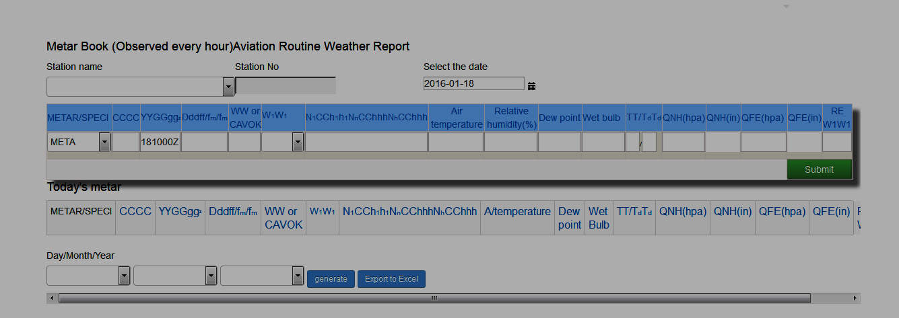

1. To begin hourly data entry, click on the drop down menu arrow located below the “**Station name**” and select the appropriate station.
2. **The “Station number”** will be automatically computed for the user once they select the station name. Of which these will also be got from the Database.
3. Select the year, month and day in the under the **“Select the date”.**
4. To enter values manually, click on the desired box and type in the value. You can move to the next box by clicking on it and some text field boxes will automatically display data after manually input of data into other text boxes.

**Metar Value Data Fields.**

|  |  |  |
| --- | --- | --- |
| **Value Data Fields Names** | **Description** | **Constraints** |
| Metar/Spec | Select either Metar/Speci from the drop down arrow. |  |
| CCCC | M**a**nually input this field. |  |
| YYGGggz | Automatically computed. |  |
| Dddff/fm/fm | Click the text box to enter this value. |  |
| WWORcavok | M**a**nually input this field |  |
| W1W1 | Select Fg,Hz,Ra,Ts from the drop down arrow |  |
| N1CCh1h1NnCChhhNhCChhh | M**a**nually input this field |  |
| Air Temperature | Input the temperature for that hour into this field |  |
| Relative Humidity(0\0) | Record the humidity in percentage |  |
| Dew Point | Enter the dew point |  |
| Wet Bulb |  |  |
| TT/TdTd | Automatically computed. |  |
| QNH(hpa) | M**a**nually input this field |  |
| QNH(in) | M**a**nually input this field |  |
| QFE(hpa) | M**a**nually input this field |  |
| QFF(in) | M**a**nually input this field |  |
| REW1W1 | M**a**nually input this field |  |

1. To save your record and exit the form click the **“Submit”** button.
2. Once you have entered data successfully it will be viewed below this form.
3. You can also view data that was previously entered by inputting the date from which you want to view the data then click the **“GENERATE”** button that will display the data accordingly and you can therefore export this data to Excel.

**REPORT GENERATION.**

This will generate repots according to the data that has been input by the observers. This can be found under the **“Reports”** tab when one has logged into the system.

**RAINFALL CARD (Monthly Rainfall Report)**

This will be able to display rainfall that was recorded in a specific month. This report will generated its information from the data entered in the “**Daily periodical rainfall Form**”

Below is a screen shoot of how it will be displayed.

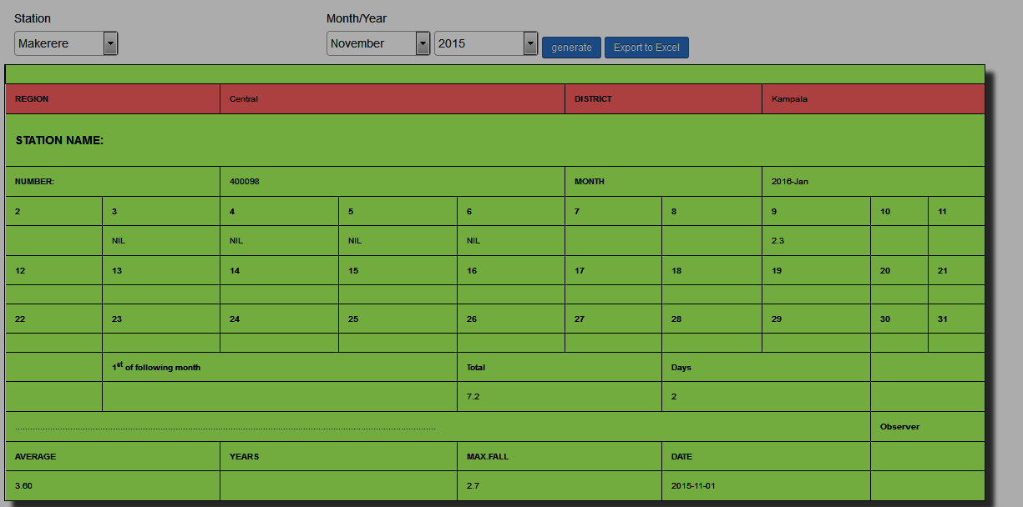

Diagram.

1. To generate a monthly rainfall report click on the drop down menu arrow located below the “**Station name**” and select the appropriate station.
2. **The “Station number”** will be automatically computed for the user once they select the station name. Of which these will also be got form the Database.
3. Enter the month and year by clicking the drop down menu arrow located to below the**“Month/Year”** box to be able to be able to select the year, month.
4. To display the monthly rainfall data you click the **“generate”** button.
5. You can export this report to Excel by clicking the **“Export To Excel’’** button.

**TEN DAY REPORT (DEKADAL):**

This will be able to display daily data entered for ten days at different Times of Observation from the first day you select to the tenth day you select.

The data displayed will be Temperature, Relative Humidity and The Wind Speed at these times of Observation (9:00am,3:00pm and --------

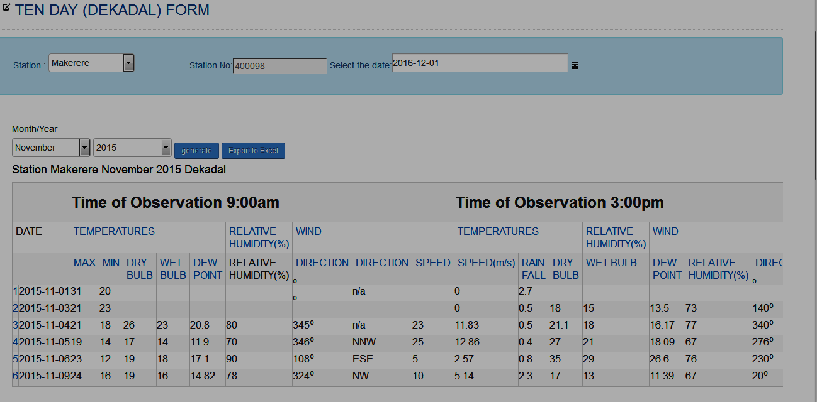

1. To generate a ten day dekadal report click on the drop down menu arrow located below the “**Station name**” and select the appropriate station.
2. **The “Station number”** will be automatically computed for the user once they select the station name. Of which these will also be got form the Database.
3. Enter the month and year by clicking the drop down menu arrow located to below the **“Month/Year”** box to be able to be able to select the year, month.
4. To display the ten day dekadal report data you click the **“generate”** button.
5. You can export this report to Excel by clicking the **“Export To Excel’’** button.

**FORM NO.6A REPORT**

This report displays the rainfall received in each month from the month you select. Below is screen shoot of the how this report will display its data.

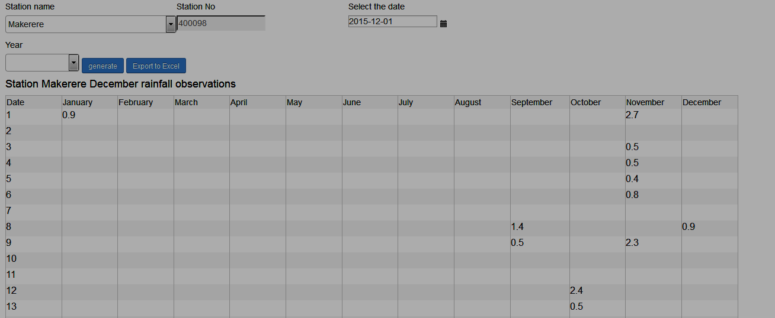

1. To generate this report click on the drop down menu arrow located below the “**Station name**” and select the appropriate station.
2. **The “Station number”** will be automatically computed for the user once they select the station name. Of which these will also be got form the Database.
3. Enter the month and year by clicking the drop down menu arrow located to below the **“Month/Year”** box to be able to be able to select the year, month.
4. To display this report data you click the **“generate”** button.
5. You can export this report to Excel by clicking the **“Export To Excel’’** button.

**WEATHER MONTHLY SUMMARY (FORM 10).**

This form will be able to display the monthly weather summary for each month. Below is screen shoot of the how this report will display its data.

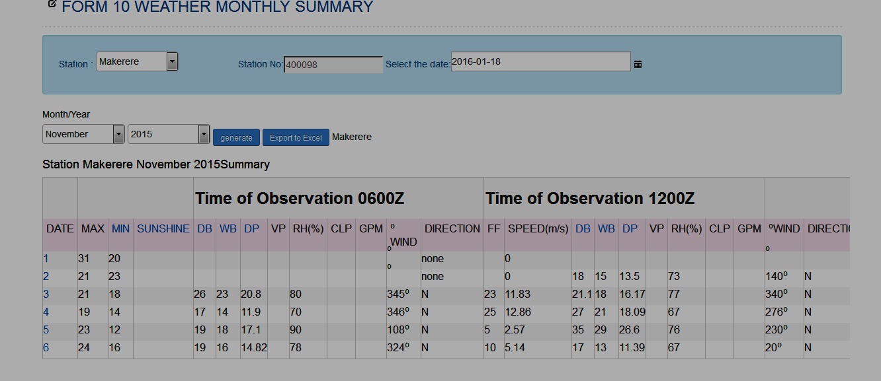

1. To a weather monthly summary report click on the drop down menu arrow located below the “**Station name**” and select the appropriate station.
2. **The “Station number”** will be automatically computed for the user once they select the station name. Of which these will also be got form the Database.
3. Enter the month and year by clicking the drop down menu arrow located to below the**“Month/Year”** box to be able to be able to select the year, month.
4. To display the weather monthly summary data you click the **“generate”** button.
5. You can export this report to Excel by clicking the **“Export To Excel’’** button.

**MONTHLY CLIMATOLOGICAL OBSERVATIONS**

**Explanation:**

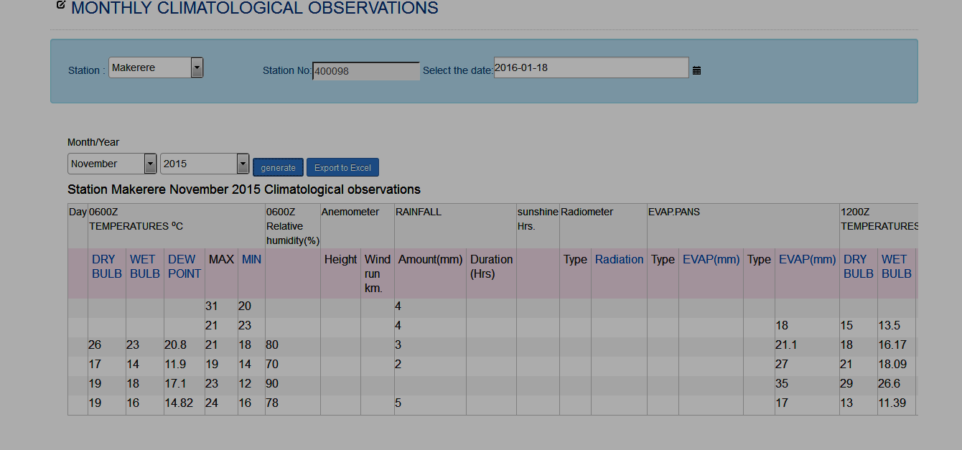

1. For a monthly climatological observations report click on the drop down menu arrow located below the “**Station name**” and select the appropriate station.
2. **The “Station number”** will be automatically computed for the user once they select the station name. Of which these will also be got form the Database.
3. Enter the month and year by clicking the drop down menu arrow located to below the**“Month/Year”** box to be able to be able to select the year, month.
4. To display the monthly climatological observations Report data you click the **“generate”** button.
5. You can export this report to Excel by clicking the **“Export To Excel’’** button.

**CALENDARS AND SCHEDULES**

To be able to display and mark any schedule that you might want to mark on the Calendar.

Click the **“CALENDARS AND SCHEDULES”** Tab then click on the tabs aligned to your right. You can click month, week, day.

Once this is done for a month a calendar like type of form will be displayed, click on the appropriate day that you want to place your schedule thereafter a pop-up window will be displayed to be able to enter the name of the event you wish to mark on that day of the month.

For the week tab when clicked it will display a long list of the days in the week you want to place an event.

For a Day it will display the hrs in a day that you can click on to be able to place an event.

**SETTING THE STATION INFORMATION**

Open WIMEA and log in.

Click on the Station link.Go ahead and click on the ADD Station. This will be display a form with the following fields.

As the shown in the figure below.

|  |  |
| --- | --- |
| **Data Field** | **Expected data to be entered** |
| Number | This will be the station number |
| Name | Name of the station |
| Location | Where this station is located |
| Code | Unique code for the station |
| Latitude |  |
| Longitude |  |
| Altitude |  |
| Type |  |
| Status |  |
| Submitted |  |

Setting Instruments

|  |  |
| --- | --- |
| Name |  |
| Station |  |
| Date of Registered |  |
| Manufacturer |  |
| Description |  |
| Submitted On |  |
|  |  |
|  |  |

Setting Elements

|  |  |
| --- | --- |
| Name |  |
| Abbreviation |  |
| Type |  |
| Units |  |
| Scale |  |
| Limits |  |
| Description |  |
|  |  |